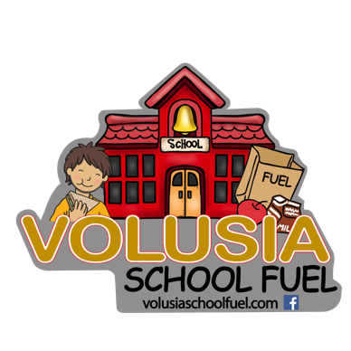

**Volusia School Fuel Permission Form – 2024/2025 School Year**

Dear Parent/Guardian,

Area donors are proud to offer **“Volusia School Fuel,”** a weekend child-feeding program. This elementary child nutrition program is designed to send child-friendly food home to **hungry children over the weekends who may struggle to have adequate food at home.** Priority will be given to those children who receive free or reduced school lunches.

If you are struggling and need assistance feeding your child on weekends, we would like to give your child the opportunity to participate in our “Volusia School Fuel” program that will be available this school year.

**On Fridays** or the last day of school each week, the school coordinator will see that your child discretely receives a **free bag of food** in his or her backpack before the school day ends. The food items will be for them to take home and eat over the weekend.

Research suggests that adequate nutrition has a positive link for your child’s learning and behavior capabilities. If you feel like your child or family would benefit from this, **please sign the bottom of this letter and return it to the school office.**  We will make every effort to put your child’s name on our distribution list as the numbers of sacks are limited. Your response will be kept confidential.

Thank you,

**Please fill out the following information, if you would like your child and/or children to participate in our “Volusia School Fuel” program. Food will only be provided to children that attend the participating school.**

Child’s Name ________________________________________________________________________________

Grade _____________________ Teacher ________________________________________________________

List any food allergies _________________________________________________________________________

List other children in same school and their grade:____________________________________________________

_____________ Elementary and Volusia School Fuel, Inc. are not responsible for any allergic reaction my child may have to the food items supplied. **It is my responsibility to look through the food items before giving them to my child to avoid any allergic reaction.**

Therefore, by signing below, I release ___________ Elementary, Volusia School Fuel, and Volusia County Schools harmless against all liabilities, damages, losses, or claims resulting from the food.

Parent/Guardian **Signature:** _____________________________________________ **Date:** _________________

**PRINT** Parent/Guardian Name: __________________________________________________________________

Participants are not discriminated against because of race, sex, color, national origin, age, or disability.